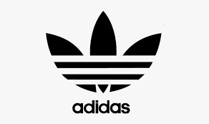

ADIDAS



* SPECIFICATIONS

Brand : Adidas-official

Items : Hoodie, shirts , pants , etc.

DETAILS

|  |
| --- |
| NIKE, Inc., together with its subsidiaries, designs, develops, markets, and sells athletic footwear, apparel, equipment, and accessories worldwide. The company offers NIKE brand products in six categories. |